4th Sunday of Easter Mother’s Day

CHURCH SCHEDULE – HORARIO DE LA IGLESIA
May 12 – May 19, 2019
Sunday  Domingo  4th SUNDAY OF EASTER | 8:15 am  9:00 am  10:15 am  11:00 am | Confessions  SUNDAY MASS: Pro Populo  Confessions  SUNDAY MASS: Edward B. Cerniglia†
Monday  Lunes | 9:00 am  7:00 pm | WEEKDAY MASS: William Newsom  Oremus Program – Fellowship Hall
Tuesday  Martes |  | NO WEEKDAY MASS:  Fr. Coleman’s Day Away
Wednesday  Miercoles | 5:30 pm  6:00 pm  6:15 pm  7:00 pm  7:15 pm | WEEKDAY MASS: Souls in Purgatory†  Faith Formation for K – 4th grade (Conference Center)  Staff Meeting (Outer Office)  Faith Formation Announcements (Church)  Faith Formation for 5th – 12th grade (Conference Center)
Thursday  Jueves | 9:00 am  6:00 pm | WEEKDAY MASS: Darren Balkey  RCIA – Conference Center  Knights of Columbus Meeting
Friday  Viernes | 9:00 am  After Mass  9:30 am | WEEKDAY MASS: Madison Turner  Confessions  Adoration and Benediction until 10:30 am
Saturday  Sabado | 9:00 am  10:00 am  5:00 pm  7:00 pm | WEEKDAY MASS: Sam Edwards  Lay Carmelite Community Meeting (Conference Center)  Confirmation Preparation (Conference Center  MISA EN ESPANOL: Pro Populo
Sunday  Domingo  5th SUNDAY OF EASTER | 8:15 am  9:00 am  10:15 am  11:00 am  2:00 pm | Confessions  SUNDAY MASS: Linda Tiller†  Confessions  SUNDAY MASS: Candida Hernandez†  The Men (Conference Center)

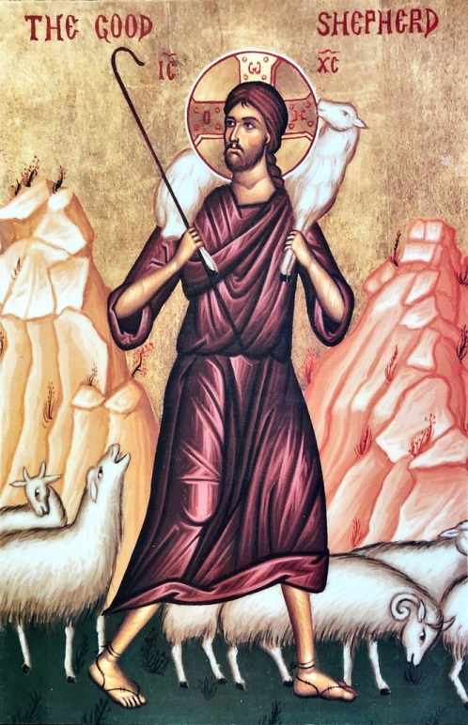
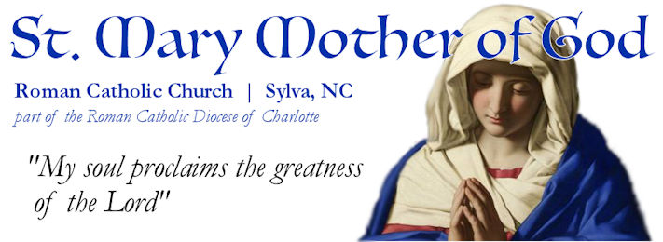
Pastor:

Rev. Casey Coleman
cacoleman@charlottediocese.org
Deacon:
Deacon Matt Newsome
ccm@wcucatholic.org
Executive Assistant:
Susie Bryson
dsbryson@charlottediocese.org
Faith Formation:
Luci Bohorquez Pacheco
lbohorquepacheco@charlottediocese.org
Hispanic Ministry:
Alma & Eleazar Flores 828-506-1215
Martha & Javier Leon 828-507-4003
Sacramental Emergency:
828-631-0576
MASS TIMES:
Saturday Vigil (Spanish): 7:00 pm
Sunday: 9:00 am & 11:00 am
Mon, Thu, Fri, Sat: 9:00 am
Wednesday: 5:30 pm
CONFESSION:
Sunday: 8:15 am & 10:15 am
Wednesday: 4:45 pm
Friday: 9:30 am
Saturday: 5:45 pm

22 Bartlett Street, Sylva, NC 28779 (828) 586-9496
www.StMaryMotherofGod.com | StMaryMotherofGod@charlottediocese.org
www.facebook.com/stmarysylv

4th Sunday of Easter Mother’s Day

Congratulations to 1st Communicants
We rejoice with all of our 1st Communicants and their families on the joyous occasion of their reception of communion for the first time on May 11th at the Saturday 7:00 pm Mass.

Office Hours for Sundays
On most Sundays, 30 minutes after each Mass - the office will be open for purposes of room scheduling and for mass intention requests. When the office is not open, please use the dropbox outside of the office. Please use the envelope that is provided for mass intention requests and include your contact information. Also please note, it could take 3-5 business days for scheduling. You will receive an email or call to confirm the request.

Collection Counters Needed
In need of 8-10 counters that will make up teams of two to count the weekly collection. The teams will rotate weekly to count once a month the collection. The day and time is yet to be determined. Please see Fr. Coleman or email if you are interested or have questions.

Smoky Mountain Faith Formation Vicariate Meeting – Saturday, May 18
Catechists interested, please join us in Hayesville, NC for the quarterly meeting for Faith Formation. At 1:00 pm there will be a Presentation: Meeting the Needs of Those with Disabilities presented by Susie Bryson, Employment Transitional Specialist with Webster Enterprises on how to foster an environment within faith formation classes for those with disabilities as community.

Usher Training – Saturday, June 1st
There will be a mandatory training from 12:00 -2:00 pm. This day will include lunch, talk, and training. If you are unable to be present, please email Susie Bryson or call the office prior to the date.

SCHEDULES NEXT WEEK |  | 9:00 am | 11:00 am
May 12th  5th Sunday of Easter | Reader | Caryn Raming | Jonathan Fischer
 | EMHCs | Debbie Keener | Wayne Haire
 | Ushers | Brian Boch, David Karuru | Kathy McFadden, Robin Starrs
 | Servers | Brian Raming, Todd Wenberg | Josiah, Malcolm, Alister Newsome, Gideon Freeman
Our Lady of Fatima |  | May 19 – Sandy Sauer | May26 - available
Last Sunday Weekly Offertory: $2840.00.
2019 DSA: $3,750.00 received + $1,775.00 pledged toward our $17,479.00 goal.
4th Sunday of Easter Mother’s Day

LITURGICAL AID - AYUDA LITURGICA
Proper (Cycle C-I) | Mass Readings - Lecturas de Misa
SUNDAY (DOMINGO)  Mother’s Day  World Day of Prayer for Vocations | Acts 13, 14, 43-52  Revelation 7,9, 14b-17  John 10: 27-30 (51)
Monday (Lunes)  Our Lady Of Fatima | Acts 11: 1-18  John 10: 1-10
Tuesday (Martes)  St. Matthais, Apostle | Acts 1:15-17 20-26  John 12:44-50
Wednesday (Miercoles)  St. Isidore | Acts 12:24-13-5a  John 12:44-50
Thursday (Jueves) | Acts 13:13-25  John 13:16-20
Friday (Viernes) | Acts 13:26-33  John 14:1-6
Saturday (Sabado)  St. John I, Pope and Martyr | Acts 13:44-52  John 14:7-14
SUNDAY (DOMINGO)  5th SUNDAY OF EASTER | Acts 14:21-27  Revelation 21:1-5a  John 13:31-33a, 34-35

PLEASE KEEP IN YOUR PRAYERS - POR FAVOR GUARDE EN SUS ORACIONES:

Justin Basenese, Jacki Bautista, Michael Burke, Jim Clark, Sheila Coller, Will Crain, Rory Glover, Monica Glover, Debbie Hentschel, David Hmielewski, Barbara Jakiela, Skip Karby, Rita Lamanna, Paul Lormand, Daniella Machado, Tim Mann, Karen Matulis, Peter Namotka, Georgia Newsom, William Newsom, Jr., William Newsom, Sr., William Owen, Cathleen Pilch, Zig Pilch, Cynthia Pitts, Alicia Ramirez, Stuart and Janet Snyder, Jay Thorne, Allen Thurston, Joshua Turner, Lewis Turner, Jim Waters, Joe Waters, Pauline Watson, Bonnie Welch, Elaine Willkes

Those in Nursing Homes and Homebound: Pat Bryson, Theresa Campbell, Moon Chung, Alicia Elias, Rosemary Finnegan, Elba Hernandez, John Huffman, Anna Morrill, and Lorraine Sclafani

Those Called to Active Duty: Luke Turner, Jason Coleman
Friends in Religious Life: Sr. Catherine, OCD

And the intentions for all of the prayers written in our parish book of prayers.

